ROC Curve

### Receiver Operating Characteristic curve is a graphical representation of the performance of a binary classification model at various classification thresholds..

#### It plots the true positive rate (TPR) vs the false positive rate (FPR) at different classification thresholds.

# Area Under Curve (AUC) Curve:

The AUC curve represents the area under the ROC curve. It measures the overall performance of the binary classification model. As both TPR and FPR range between 0 to 1, So, the area will always lie between 0 and 1, and A greater value of AUC denotes better model performance.

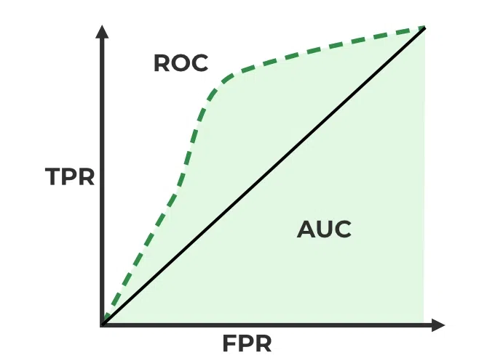

# Key terms used in AUC and ROC Curve

### 1. TPR and FPR

* TPR – True Positive Rate
* FPR – False Positive Rate

# Confusion Matrix for a Classification Task

### 2. Sensitivity / True Positive Rate / Recall

Basically, TPR/Recall/Sensitivity is the ratio of positive examples that are correctly identified. It represents the ability of the model to correctly identify positive instances.

### 3. False Positive Rate

FPR is the ratio of negative examples that are incorrectly classified.

### 4. Specificity

Specificity measures the proportion of actual negative instances that are correctly identified by the model as negative. It represents the ability of the model to correctly identify negative instances